Adcash OÜ

**Product Technical Support Spetsialist assigment**

Vadim Kööp

Tallinn 2019

**Table of Contents**

Task 1 - External user visits our homepage: 3

Task 2 - SQL: 4

Task 3 – IP Check 5

Task 4 – Log analysis 6

Task 5 – Mathematics 7

TASK 6 – Statistic analysis 8

TASK 7 – Web code 9

TASK 8 - Publisher 10

TASK 9 – IT logic 11

# Task 1 - External user visits our homepage:

An external user visits our homepage and performs a registration. Registration action does not

reach our internal system.

Given the information above, compile an answer to a reporter to receive more information.

A follow up answer is given:

Publisher, Date of registration 12.08.2018. ID client ID: 123456A. URL: example.com

Based on the information provided, create a mock-up of a bug ticket fully explaining a problem to

the internal dev team. Use an industry standard while describing a bug:

IF, THEN

Reproduction steps

Acceptance criteria

TIP:

This bug does not exist in reality. Use your imagination and a best judgement of a problem.  
  
**ANSWER**

Publisher, Date of registration 12.08.2018. ID client ID: 123456A. URL: example.com  
Client can not register the account. At the moment we got the technical problem with our service.  
We need to check it and error messages!

We create a technical ticket with all information that we have, then we transform it from normal text to “Dev language”.

We provide all tehnical information to Dev team and ask them in polite way to help us.

Task 2 - SQL:Given an online shopping system with the following main tables in MySQL:

CREATE TABLE IF NOT EXISTS `users` (

`id` int(11) NOT NULL AUTO_INCREMENT,

`password` varchar(65) NOT NULL,

`email` varchar(100) NOT NULL,

`name` varchar(200) NOT NULL,

`last_login` datetime NOT NULL,

PRIMARY KEY (`id`),

UNIQUE KEY `email` (`email`)

) ENGINE=InnoDB DEFAULT CHARSET=utf8;

CREATE TABLE IF NOT EXISTS `orders` (

`id` int(11) NOT NULL AUTO_INCREMENT,  
`user_id` int(11) NOT NULL,

`status` enum('pending','progress','delivered') NOT NULL,

`date` datetime NOT NULL,

`amount` decimal(12,2) NOT NULL,

PRIMARY KEY (`id`),

KEY `user_id` (`user_id`)

) ENGINE=InnoDB DEFAULT CHARSET=utf8;

Write the following queries (one per line), only in SQL. Using PHP is not allowed!

A) Get the number of pending orders of user with e-mail

' john@example.com '

B) Get id, email and name of the users who made an order today.

C) Get id, email and name of the users who haven't made any order ever.

D) Get id, email, name, and the total orders amount of all users whose total order amount sum is

at least 100 euro.  
  
**ANSWER**

A) select count(status) from orders left join users on orders.user_id == users.id where status == 'pending' and email == 'john@example.com'B) select id,email,name from users left join orders on user.id == orders.user_id where datepart(dayofyear, date) == datepart(dayofyear, curdate()) and datepart(year, date) == datepart(year, curdate())

Task 3 – IP CheckProvide information (ISP, GEO) for IP: 217.13.124.96.

**ANSWER:**  
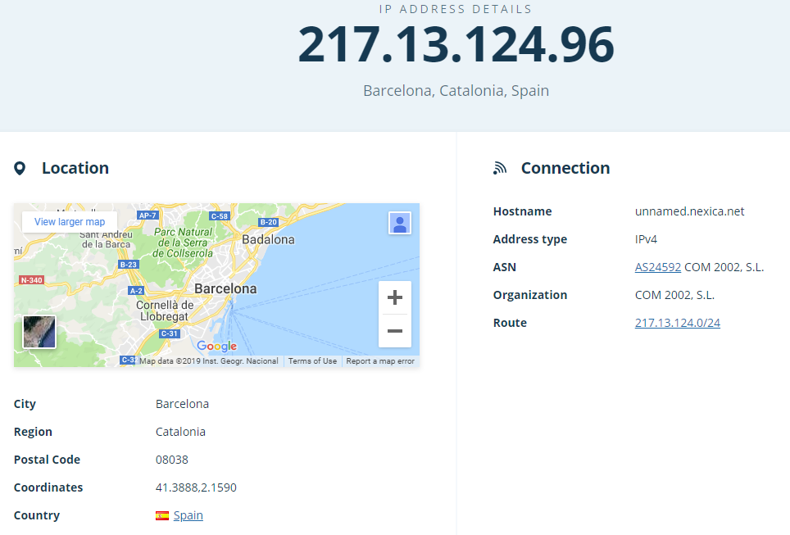

Task 4 – Log analysisProvide all the information you can salvage from the following log entry: Provide all the information you can salvage from the following log entry:

180.178.120.200 - BG - [23/Apr/2014:22:54:45 +0000] "POST /orders/edit/id/2/ HTTP/1.1" 404

1024 "http://yahoo.com" "Mozilla/5.0 (X11; U; Linux x86_64; it-it) AppleWebKit/534.26+ (KHTML,

like Gecko) Ubuntu/11.04 Epiphany/2.30.6"  
  
**ANSWER:**  
180.178.120.200 - BG - [23/Apr/2014:22:54:45 +0000] - **HERE IS GIVEN IP ADRESS, Date and Time.**  
"POST /orders/edit/id/2/ HTTP/1.1" 404 1024 – **HERE WE POST INFORMATION USING THE HTTP.  
404 – means NOT FOUND  
1024 – I guess it is the size of information**  
"http://yahoo.com" "Mozilla/5.0 (X11; U; Linux x86_64; it-it) - **HERE OPEN** [http://yahoo.com](http://yahoo.com/) **With Mozilla Firefox browser using the Linux x86_64 operation system.**  
 AppleWebKit/534.26+ (KHTML, like Gecko) Ubuntu/11.04 Epiphany/2.30.6" – **Using the AppleWebKit Ubuntu version 11.04**

# Task 5 – Mathematics

Perform a task to calculate an amount of the invalid traffic.

A campaign is not allowed to spend more than 100 EUR per day. Traffic from Android devices is

not allowed.

Over the past 7 days daily traffic breakdown:  
  
Monday: 157 EUR

Tuesday: 58 EUR

Wednesday: 989 EUR  
Thursday: 122 EUR

Friday: 57% increase from Tuesday

Saturday: 878 EUR

Sunday: 150 EUR

Android traffic share for all the days: 14.4%

Perform a calculation of the wrong traffic in EUR

a) daily

b) weekly  
  
**ANSWER:**  
**A) Daily**Monday: 157 EUR – 100 EUR = 57 EUR (wrong traffic in EUR)  
Tuesday: 58 EUR 🡪 Wrogn traffic is missing!  
Wednesday: 989 EUR – 100 EUR = 889 EUR (wrong traffic in EUR)  
Thursday: 122 EUR – 100 EUR = 22 EUR (wrong traffic in EUR)  
Friday: 91.06 EUR 🡪 Wrogn traffic is missing!  
1) 58 * 1.57% = 91.06 EUR (Fridayt traffic)  
Saturday: 878 EUR – 100 EUR = 778 EUR (wrong traffic in EUR)  
Sunday: 150 EUR – 100 EUR = 50 EUR (wrong traffic in EUR)  
  
**B) Total traffic:**  
1) 157 + 58 + 989 + 122 + 91.06 + 878 + 150 = 2445.06 (weekly total traffic)  
2) 2445.06 - 352.08864 (14.4 % android traffic) = 2092.97136 EUR (traffic without android)  
3) 2092.97136 EUR – 700 EUR = 1392.97136 EUR (wrong weeakly traffic)   
  
I am not sure, do I need to do additional calculation with Tuesday and Friday, because at these days traffic is good!

# TASK 6 – Statistic analysis

Campaign should only run on weekdays. We get paid 1,5 euro for 1,000 impressions. It aims for traffic from France, but because of a glitch, on **Wednesday** and **Thursday**, 25% of traffic comes from Belgium.

Mo 150,500 impressions

Tu 125,200 impressions

We 120,000 impressions

Th 160,200 impressions

Fr 170,800 impressions

Sa 20,600 impressions

Su 25,400 impressions

Please calculate the amount in Euro that should be billed from the client for the correct traffic.  
  
**ANSWER:**

If I understand correctly correct traffic is the traffic which is coming from France.  
  
1) We find 75% of the correct traffic at Wednesday and Thursday.  
Wednesday 🡪 120,00 * 0.75 = 90,000 impressions (correct traffic)  
Thursday 🡪 160,200 * 0.75 = 120,150 impressions (correct traffic)

2) 150,500 + 125,200 + 90,000 + 120,150 + 170,800 + 20,600 + 25.400 = 702,650 impressions (total for week)

3) (702650 / 1000) * 1.5 EUR = 1053.975 EUR (correct bill from the client for the correct traffic)

# TASK 7 – Web code

Fix the following HTML code:

<"table class\\//><div attr= style='"><span&gt;&nbsp;</spann></</table>  
  
**ANSWER:**  
<table class = ""> <!-- Write the class! -->

<div style = "background-color:lightblue"> Just Test </div>

<span> Just test </span>

</table>  
  
**I am not sure what you wanted to write here. I just created the new code with correct syntax.**

# TASK 8 - Publisher

Publisher registered in Adcash, copied the tag provided from the publisher panel and applied it to his website. However, ads are not shown. What are the steps you do to find out the reason why?

Write down a troubleshooting / debugging plan.  
  
**ANSWER:**I need more details about your service that I could see how this tag works.  
1) But I guess that tag is working correctly and the client has done something wrong.  
2) First of all I will check the registration and account settings of the client.   
3) After that, I will make sure that everything is done correctly on our part I will check the client part.  
4) I will check the technologies client is using and how he is using the tag.  
5) I think that you provide instructions how to use tags correctly.

# TASK 9 – IT logic

1. Take a look at the following page:

https://adcash.myadcash.com/register

2. Write a small walk through (step-by-step guide that can be used by external users) of the

registration and account activation process.  
  
  
**ANSWER:**1) If you have account then click at the Login  
  
  
If you do not have the account then you need to register it!2) Select account type: **buy traffic** or **sell traffic** or **advertiser and publisher**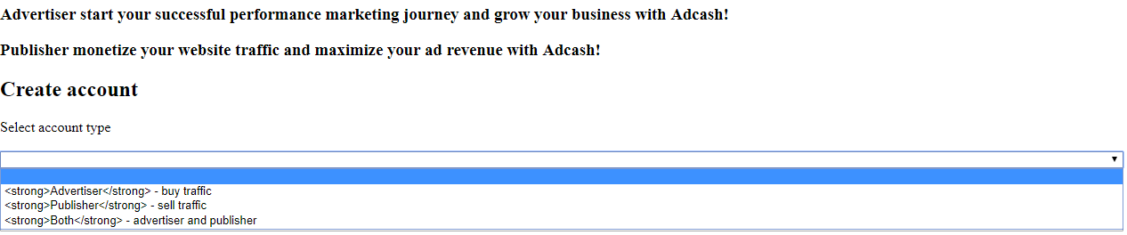3) Choose the billing type: **Euro** or **Dollar**  
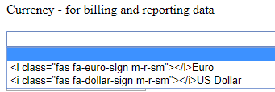4) Write your **email** and **password**.   
Click on the “**terms and conditions**” and read it!  
If everything is **OK** agree with this! (click on the empty square)  
If you want to get information about latest offers click on the empty square.  
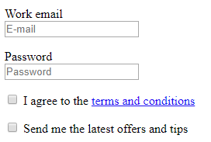  
5) Check your details if everything is correct click “register” button.